. CHEMICAL ENGINEERING TRANSACTIONS  VOL. , 2024 | A publication of
The Italian Association
of Chemical Engineering
Online at www.cetjournal.it

Guest Editors: Leonardo Tognotti, Rubens Maciel Filho, Viatcheslav Kafarov
Copyright © 2024, AIDIC Servizi S.r.l.
ISBN 979-12-81206-09-0; ISSN 2283-9216

On the Applications as Catalytic Support of Biochars

obtained by Pyrolysis of Waste Biomasses
Federica Menegazzoª, Elena Ghedini*ª, Lilia Longoª, Davide Baldassinª, Somayeh Taghavi^{b,a}, Michela Signorettoª

ªCATMAT Lab, Department of Molecular Sciences and Nanosystems, Ca’ Foscari University of Venice and INSTM-RU Ve, Via Torino 155, 30172 Venezia Mestre, Italy
^{b}Faculty of Chemistry, University of Mazandaran, 47416-95447 Babolsar, Iran
corresponding author: gelena@unive.it
Biochars, as carbon rich materials with tuneable properties and a chemical composition of various doping and functionalized elements, are a promising option for many different applications. In this work, biochars were obtained by pyrolysis of different biomasses from vegetal (hazelnut shells, vine wood waste, barley waste, rice husks, and Sargassum, macroalgae of Venetian lagoon) and animal (leather tannery waste) origins. The activation was performed either by CO₂ or steam physical treatment at high temperature. Biochars and activated biochars were characterized by elemental analysis, N₂ physisorption, and FTIR techniques. The chemical, morphological, and textural properties of the biochars were strongly affected not only by the origin of the starting biomass, but also by pyrolysis conditions and activation parameters. Some examples of applications of these activated biochars as support for different metal catalysts in biomass valorisation reactions will be presented. In particular, the following samples were investigated:
i) Ru/C catalysts for the hydrogenation of 5-hydroxymethylfurfural.
ii) Pd/C catalysts for benzaldehyde hydrogenation to toluene.
iii) Ni/C catalysts for the conversion of levulinic acid to γ-valerolactone.
The catalytic performances were discussed comparing the prepared samples with commercial references. It can be postulated that biomass wastes properly treated with pyrolysis can not only be recycled but also upgraded.
  - Introduction
Due to the increase of the world population and of the average level of quality of life, the need of resources is highly increasing. At the same time, climate change and the exhaustion of non-renewable fossil reserves have increased the need to replace hazardous processes and non-renewable resources with green technologies and sustainable biobased sources. Biomasses can be considered as a renewable resource because they can be replenished over a relatively short timescale, and they are limitless in supply. Moreover, they are biodegradable, readily accessible, and low cost (De Corato et al, 2018). Therefore, in a world where resources are depleting at an alarming rate and waste generation is increasing, it is essential to improve the recycling of materials, following the principles of circular economy. Now, recycling is not enough anymore: beyond recycling there is upcycling. The latter is a relatively recent term which consists of using recyclable materials to obtain products with a higher value than that of the original material, transforming waste into resource. Therefore, one of the main challenges for scientists nowadays is to provide the chemical industry with new tools to upgrade waste biomasses. The latter are considered second-generation biomass and consist, for example, of wastes of vegetal origin such as wood, organic waste, and food crop waste, or of animal origin such as leather tannery waste. Biomasses can be transformed by conventional thermochemical processes which mainly include liquefaction, gasification, and pyrolysis. The latter is the thermochemical decomposition of biomass which occurs at high temperature in an inert atmosphere. Thermal decomposition of the organic components of biomass begins at 350 °C - 550 °C, but temperatures can be raised to 700 °C - 800 °C for further transformation. Under pyrolysis conditions, the long chains of C, H and O compounds of the biomass split into smaller molecules. The process is strongly influenced, apart from the origin of the biomass, by the reaction temperature, the rate of heating, the residence time of the vapours in the reactor. Biomass pyrolysis products include a gas fraction denoted as biogas, a liquid fraction that is the so called biooil and a solid residue, the biochar. The latter has a catalytic effect for tar cracking during pyrolysis (Volpe et al, 2016). The biochar is primarily a carbon residue with H, O, and lower quantities of N, P, and S heteroatoms. It also includes ashes composed of K, Na, Ca, Mg, Si, Al, and Fe (Pereira Lopes and Astruc, 2021). The amounts of each element and ashes in the different biochars are influenced by the origin of initial biomass, the pyrolysis conditions, and each pre- and post-treatment procedure (Ferraro et al, 2022). With respect to other carbonaceous materials, biochars can be obtained from waste materials, hence they are sustainable, and they possess tuneable chemical, textural and morphological properties. Indeed, biochars have been applied in many different sectors such as energy production, CO₂ capture, soil improver, absorbents for water depuration, and catalysis (Qian et al, 2015). Our attention was focused on the application of biochars as catalytic support, considering that catalysis is one of the 12 principles of green chemistry and contributes to achieving the sustainable development goals. As for their use as support in heterogeneous metal catalysts, the biochars obtained by a pyrolysis process are characterized by surface functional groups such as carboxyl, hydroxyl, amino, lactone groups, which can favour a good anchorage of active metal phases on the support. On the other hand, most of the biochars have a non-ordered structure with a very low surface area and weak porosity, limiting their utilization in catalytic applications. However, it is possible to boost these properties by an activation process that can be physical (with steam, CO₂, O₃) or chemical (with KOH, ZnCl₂, K₂CO₃, H₂SO₄, H₃PO₄) (Cheng and Li, 2018). These treatments lead to a partial oxidation of the carbon, developing its localized order and hierarchical porous structure and therefore increasing the surface area and porosity of the materials. Herein, the aim behind the investigation was to study the possibility of using different biochars (from vegetal and animal origins, of second and third generation of biomass) as supports for metal active phases. Therefore, after pyrolysis and physical activation with steam or carbon dioxide, the obtained biochars were applied as supports for commonly used metal catalysts (Ru, Pd, Ni) and tested in different biomass valorisation reactions.
  - Experimental
The biomasses used as feedstocks were:
-Hazelnut shells (Tonda Gentile Romana) supplied by Fattoria Lucciano Soc. Agr. s.s. (Civita Castellana, Viterbo, Italy); Broken rice grains supplied from Riseria delle Abbadesse, Grumolo delle Abbadesse, (Vicenza, Italy); Rice husks supplied from Riseria delle Abbadesse, Grumolo delle Abbadesse, (Vicenza, Italy); Vine wood waste was supplied from a cellar (Conegliano, Italy); Barley waste (Padova, Italy); Sargassum, brown macroalgae were collected in the Venice lagoon, (previously washed with tap water and distilled water, dried in air for 48 h and further dried at 110 ℃ for 2 h); Metals-free leather shaving waste obtained from PASUBIO S.p.A. tannery (Arzignano, Italy), provided by GOAST technology (LIFE16 ENV/IT/000416).
Synthesis of activated biochars
The activated biochars were synthesized by a two steps treatment of pyrolysis and activation in a lab-scale prototype plant (Carbolite custom model EVT 12 / 450B) composed of a fixed bed quartz tube inside a vertical tubular oven equipped with the lines and mass flow controllers. The pyrolysis was performed on N₂ flow (100 mL/min) from 25 °C to 700 °C, with a ramp of 5 °C/min and maintained at 700 °C for 0,5 h. The biochars were activated or by steam at 850 °C for 1,5 h, heating rate 10 °C/min, H₂O:N₂=1:1 flow (100 mL/min), or by CO₂ (100 mL/min for 4 h). The activated biochars were washed with a 1M HCl solution, sonicated for 1 h, filtered, washed with deionized water until neutral pH, and finally dried at 110 °C for 12 h. All materials were grinded and sieved to the particle size <180 μm in diameter.
Synthesis of metal supported catalysts
0.5 wt.% Ru based catalysts were synthetized by wet impregnation using an aqueous solution of RuCl₃. After stirring at 600 rpm for 18 h at 25 °C and drying at 110 °C, the catalysts were treated at 550 °C for 2 h in N₂ flow and finally reduced at 300 °C in H₂ flow for 3 h. A commercial Ru/C catalyst (Evonik Noblyst® P3060 5% Ru) was used as a reference.

0.5 wt% Pd based catalysts were synthesized by wet impregnation using an aqueous solution of H₂PdCl₄. The metal was reduced by a HCOONa solution at 80 °C. After filtration and washing with deionized water until the complete elimination of chlorides, the catalysts were dried at 110 °C for 18 h.

Biochars were doped with 10 wt% of Al by precipitation using an aqueous solution of Al(NO₃)₃. Then,10 wt.% Ni catalysts on Al doped biochars were prepared by wet impregnation using an aqueous solution of Ni(NO₃)₂. The samples were calcined at 550 °C in N₂ for 4 h and then reduced at 400 °C in H₂ for 3 h.
Characterizations techniques
UNICUBE organic elemental analyzer (Elementar) was used for the CHNS elemental analyses. The ASTM-D7582 protocol was applied to calculate the inorganic residues (ashes) amount using a TGA 8000 (PerkinElmer) for the thermal analyses. The oxygen content was determined as O% = 100 - (C% + H% + N% + S% + ash%). Ashes were determined after sonication with a solution 1 M HCl solution for 1 h. Surface areas and pore size distributions were determined by N₂ physisorption analyses at -196 °C by means of a Tristar II Plus (Micromeritics). A spectrometer (Perkin Elmer) was used for the Fourier transform infrared (FTIR) analyses. The concentrations of the metallic active phases were determined either by inductively couple plasma – optical emission spectrometry (ICP-OES, Agilent Technology 4210 MP-AES) or by atomic absorption spectroscopy (Perkin-Elmer, 100 spectrometer). The catalysts were previously digested in aqua regia.
Catalytic tests
HMF hydrogenation was carried out in a stainless-steel autoclave with a molar ratio HMF:Ru=125:1 in aqueous solution. The reactor was charged with 30 bar H₂, heated up to the reaction temperature (100 °C) and stirred for 1 hr at 1200 rpm. The products were analyzed by HPLC (Agilent Technology 1260 Infinity II).
BA hydrogenation was carried out in a semi-batch reactor with a H₂ bubbler, with 20 mL of ethanol and a molar ratio BA:Pd=222:1. The mixture was stirred at 25 °C for 1 h and analyzed by gas chromatography.
The conversion of LA to GVL was performed in a stainless-steel autoclave with a molar ratio LA:Ni=12.5:1 in aqueous solution. The autoclave was pressurized with 35 bar of H₂ and the products were analyzed by HPLC (Agilent Technology 1260 Infinity II) after 4 h of reaction at 200 °C.
  - Results and discussion
Characterization of the supports
Various biomasses, both of vegetal and animal origins, and either of second or third generation, were examined and applied for pyrolysis and physical activation to optimize a proper support for metal catalysts. In details, we have upgraded these wastes:
- Hazelnut shells (H): a vegetal and agricultural waste of second-generation, and a lignocellulosic biomass that contains mainly lignin, hemicellulose, and cellulose. These are byproducts of important supply chains in Italy, which is the world’s second largest producer of hazelnuts.
- Broken rice grain (G): an industrial byproduct that derives from the whitening and polishing process of rice. It can be considered a second-generation biomass from vegetal origin, and it is rich in starch, protein, vitamins, and minerals.
- Rice husk (R): a second-generation lignocellulosic biomass. It is an agricultural or food waste of vegetal origin and it contains mainly lignin, hemicellulose, cellulose, and 30% of inorganic components, in particular silica (Alam et al, 2020). Rice is one of the most consumed cereal grains all over the world.
- Vine wood waste (V): a vegetal agricultural or food waste of second-generation biomass, typically lignocellulosic, made of cellulose, hemicellulose, and lignin. Vinification is a very important activity in Italy, which results in a large amount of this waste.
- Barley waste (B): a vegetal agricultural or food waste of second-generation biomass, typically lignocellulosic, made of cellulose, lignin and arabinoxylans and rich in protein, lipid, fiber, and vitamins. Again, a waste commonly found throughout all European Countries.
- Sargassum brown macroalgae (A) of the Venice lagoon: this is considered a third-generation biomass, rich in protein, lipid, and carbohydrates. It is not properly a waste, however Sargassum brown macroalgae has a widespread distribution in Venice Lagoon and in Po River Delta (Northern Adriatic Sea, Italy) causing some environmental damages and its reuse is highly desirable.
- Leather tannery waste (T): an industrial solid waste of second-generation biomass deriving from the tanning industry. It is a biomass of animal origin, rich in collagen fibers, proteins, and tanning agents. Again, global leather production exceeds 6.5 million tons per year and Italy is the largest leather supplier in Europe. Besides, there were very few literatures reporting activated biochar from tannery waste in catalytic application.
The chemical composition of the different carbonaceous materials was estimated by elemental analysis and ash content determination. As it can be observed in Table 1, the heteroatoms distributions of the activated biochars (denoted with A) were strongly affected by the nature of the original material. These differences are related to the complexity of the biomass structures, made of different components: cellulose, hemicellulose, and lignin are present in the materials that derive from a lignocellulosic biomass, such as for example AH or AG with notably carbon content; proteins and tanning agents are found in the animal derived biomass such as AT; proteins are also found in AB and AA, that have a different tendency to cleavage at high temperatures. On the other hand, biochar AR has a significantly lower carbon content than the other samples due to a higher number of inorganic compounds, essentially silica, as indicated by the very high ash content even after the acidic washing. AV and AB demonstrated a high O content. Sulfur was found in very small amounts in most of the samples. This could be a very appealing quality for using these carbonaceous materials in catalytic applications since sulfur could act as poison for metal active phase. Only biochar AA has a high sulfur amount (2.8 %), due to the lipid fraction of algae. Another peculiarity that should be stressed is the high N content of the AA, AT, and AB biochars. Therefore, they appear as a natural O and N dual-doped carbon with peculiar characteristic from lignocellulosic biochars. Indeed, the presence of N heteroatoms could suggest more functional groups in the supports, being crucial for a better anchorage of the active metal phases in heterogeneous catalysis applications.
Table 1: CHNS elemental analyses, ash content and surface area of the activated biochars
Label | Activated Biochar | C  (%) | H  (%) | N  (%) | S  (%) | O  (%) | Ash  (%) | Surface area  (m²/g)
AH | Hazelnut shells (steam) | 94.3 | 0.8 | 0.2 | 0.1 | 4.0 | 0.5 | 1119
AG | Broken rice grain (steam) | 87.7 | 1.0 | 1.8 | 0.1 | 8.3 | 1.0 | 828
AR | Rice husk (steam) | 39.4 | 0.5 | 0.2 | 0.1 | 3.2 | 56.6 | 626
AV | Vine wood waste (CO₂) | 82.1 | 0.9 | 1.3 | 0.2 | 13.4 | 2.1 | 690
AB | Barley waste (CO₂) | 67.0 | 1.5 | 4.0 | 0.2 | 11.6 | 15.7 | 79
AA | Algae (CO₂) | 67.1 | 1.2 | 6.8 | 2.8 | 7.9 | 14.2 | 1305
AT | Tannery waste (steam) | 81.5 | 1.8 | 6.0 | 0.5 | 7.2 | 3.0 | 907
AT | Tannery waste (CO₂) | 76.6 | 1.1 | 9.4 | 0.6 | 9.8 | 2.5 | 412

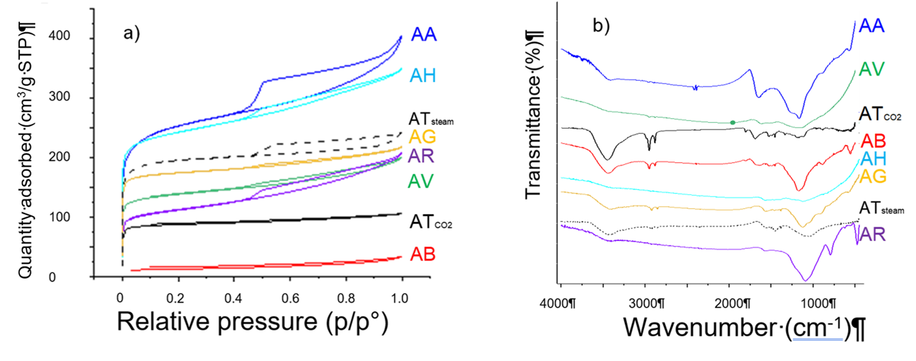
N₂ physisorption analyses were performed to evaluate surface area and porosity of the biochars. Before activation, most of them show a type III isotherm related to non-porous materials according to the IUPAC classification (Longo et al, 2023). Only biochars from rice husks and hazelnut shells exhibit type I adsorption isotherms typical of microporous materials. This is reasonably due to the lignocellulosic origin of biomasses because the decomposition of the lignin and the condensation reactions of the aromatics occurred during pyrolysis, leading to the release of volatile compounds and to the enhancement of biochar porosity (Zhao et al, 2017). The activation procedure led to an increase of the carbon content and a decrease of heteroatoms, due to the bond cleavage and rearrangement of the structure of the materials. As for the N₂ adsorption-desorption isotherms after activation (Figure 1, section a), the effect of activation is to alter the porous structure and in increasing the surface area for all the biochars. The high values of surface area (Table 1) and the pore structure of most of them are suitable for applications as catalytic support and in line with the values of activated commercial carbons. It is evident also the strong effect of the activating agent, reported as example in Figure 1 for the biochar AT activated with steam or carbon dioxide.
Figure 1: N₂ physisorption (section a) and FTIR (section b) analyses of activated biochars

To investigate the surface functionalities of the samples, FT-IR analyses were performed (Figure 1, section b). Overall, there are important differences between the spectra and bands intensities of the activated biochars, confirming the presence of heteroatoms with different contents in CHNS elemental analyses according to the different natures of the initial biomasses. For example, the more defined bands for AT, AA and AB indicate a higher number of functionalities on the surface, in line with the elemental analyses previously discussed.
The activated biochars were used as supports for different metal catalysts for biomass valorisation reactions. As for the synthesis, traditional synthetic approaches were applied, as they were commercial active carbons. In particular, the following samples were investigated:
- Ru/C catalysts for 5-hydroxymethyl furfural (HMF) hydrogenation.
- Pd/C catalysts for benzaldehyde (BA) hydrogenation.
- Ni/C catalysts for the conversion of levulinic acid (LA) to γ-valerolactone (GVL).
0.5 wt% Ru based samples were tested in the selective hydrogenation of HMF to 1-hydroxy-2,5-hexanedione (HHD), which is a building block that can be used to produce many chemicals in pharmaceutical, polymeric and solvents manufacturing. The catalytic performances of the Ru samples supported on AH and AT were compared to that of a commercial Ru/C catalyst (Figure 2, section a). The sample on AH showed the highest HMF conversion, reasonably due to the size of the Ru nanoparticles and to their dispersion on the support (Longo et al, 2022). As for the product distribution, the catalysts supported on activated biochars showed the formation of HHD, while the commercial sample was selective towards another product (2,5-dihydroxymethylfuran, DHMF). Such different selectivity might be related to the acidic properties of the biochar-based catalysts, that could influence the reaction pathway. In addition, stability and recycling properties were studied and proved to be suitable for this application, yielding promising results for industrial prospects.
Different biomasses were also used after undergoing pyrolysis and activation as support for Pd, which is a typical metal for hydrogenation. 0,5 wt %Pd catalysts were synthetized by wet impregnation and tested in the BA hydrogenation to benzyl alcohol or toluene. This is a typical reaction that can be used as a model to investigate the activity of Pd/C catalysts, being applicable for several other hydrogenations of aldehyde groups of industrial interests such as hydrogenation of 4-carboxy benzaldehyde (4-CBA) during terephthalic acid (TA) purification process, used for the PET polymerization. In fact, TA must be purified and the main impurity, that is 4-carboxybenzaldehyde (CBA) must be hydrogenated to be removed. The catalytic results showed very different performances for the various samples. Figure 2 (section b) reports some data in terms of conversion and selectivity. AG and AT showed a weaker trapping and anchorage of Pd, resulting in less Pd active sites, insufficient for converting BA under reaction conditions. Best results were obtained by AH and AR biochars, evidencing again that there are key parameters for a suitable biochar: high surface area, the ability to maintain the metal anchored, that is related also to the functional groups, the good dispersion of the active phase and the absence of pollutants, which should be removed ad hoc, or, on the contrary, the presence of doping elements (Longo et al, 2023). The best catalysts (on AH and AR) showed better performances in terms of activity, selectivity, and stability than the one synthetized on a commercial active carbon.
Finally, activated biochars were used as supports for bifunctional alumina and Ni-based catalysts for LA hydrogenation to GVL. The catalyst of the reaction should possess bifunctional properties: an active metal site for the hydrogenation step (Ni) and an acid site for the dehydration step (doped Al and acidic functional groups of activated biochar). Hence, activated biochar supported Ni only catalysts were not active in the proposed reaction due to the lack of Lewis acid site for dehydration step (Taghavi et al, 2023). As for bifunctional catalysts, the worst catalytic performance was obtained on Ni/AA. This is reasonably ascribable to the high amount of sulfur in AA biochar (Table 1), that could block Ni active sites, and poison its activity. As for the catalyst on AB, the results were not satisfactory (42% LA conversion, 27% GVL selectivity) and this could be due to the low surface area and porosity of AB support leading to low active phases dispersion. This waste probably requires harsher activation conditions. On the contrary, both AT and AV performed very well, as shown in Figure 2 (section c). The high C content of AT and AV supports (Table 1) could assist a more aromatic and stable structure of the catalysts. Moreover, the high O and N contents in AT correspond to the presences of more O,N-doped and functionalized groups (Figure 1) and a better anchorage and stability of active sites on the support. Considering the textural aspect, both these biochars possess high surface area and proper porosity for a good dispersion of Ni and Al on the support.
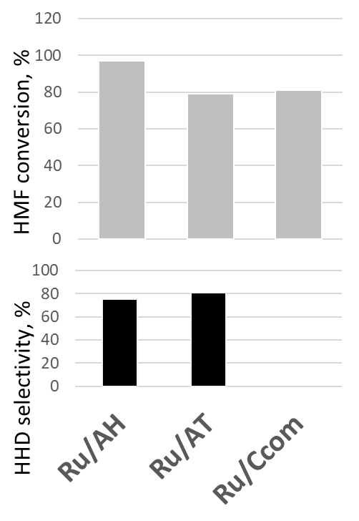
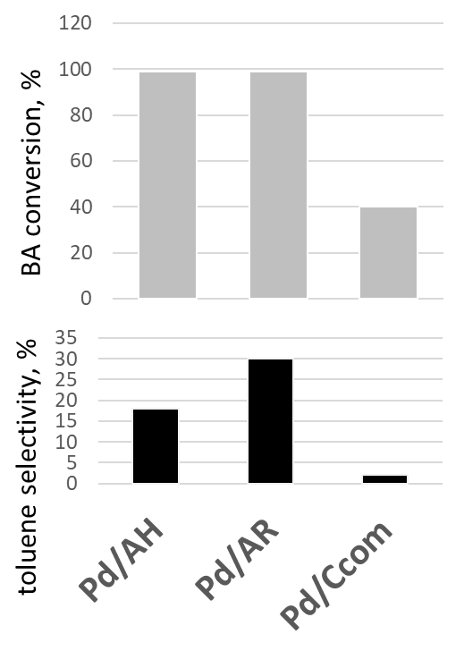
a) b) c)

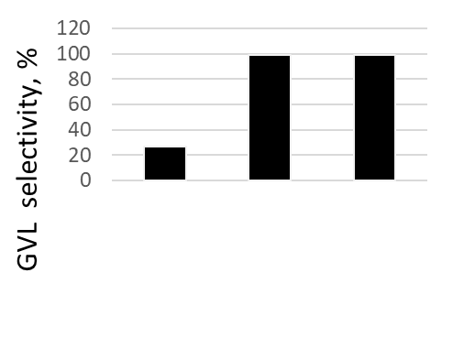
Ni/AB
Ni/AT
Ni/AV

Figure 2: Catalytic activity of Ru/C for HMF hydrogenation (section a), Pd/C for BA hydrogenation (section b), Ni/C for the conversion of LA to GVL (section c).
  - Conclusions
Biochars from wastes, as carbon rich material with suitable and tuneable properties are a promising option as catalytic support. The trick is to find the suitable conditions for pyrolysis and activation to modulate ad hoc the features of final materials for the desired specific application. Knowing that, many different local wastes could be used, showing that biomass wastes properly treated by pyrolysis can be upgraded and not only recycled, improving sustainability and circular economy.
References
Alam M.M., Hossain M.A., Hossain M.D., Johir M.A.H, Hossen J., Rahman M.S., Zhou J. L., Hasan A.T.M.K, Karmakar A.K., Ahmed M.B, 2020, The potentiality of rice husk-derived activated carbon: from synthesis to application, Processes, 8, 203–241.
Cheng F., Li X., 2018, Preparation and Application of Biochar-Based Catalysts for Biofuel Production, Catalysts, 8, 346–381.
De Corato U., De Bari I., Viola E., Pugliese M., 2013, Assessing the main opportunities of integrated biorefining from agrobioenergy co/by-products and agroindustrial residues into high-value added products associated to some emerging markets: A review, Renewable and Sustainable Energy Reviews, 88, 326–346.
Ferraro G., Pecori G., Rosi L., Bettucci L., Fratini E., Casini D., Rizzo A.M., Chiaramonti D., 2022, Biochar from lab-scale pyrolysis: influence of feedstock and operational temperature, Biomass Convers Biorefin, 1–11.
Longo L., Taghavi S., Ghedini E., Menegazzo F., Di Michele A., Cruciani G., Signoretto M., 2022, Selective hydrogenation of HMF to 1-hydroxy-2,5-hexanedione by biochar supported Ru catalysts, ChemSusChem, 15, e202200437.
Longo L., Taghavi S., Riello M., Ghedini E., Menegazzo F., Di Michele A., Cruciani G., Signoretto M., 2023, Waste biomasses as precursors of catalytic supports in benzaldehyde hydrogenation, Catal Today, 420, 114038.
Pereira Lopes R., Astruc D., 2021, Biochar as a support for nanocatalysts and other reagents: Recent advances and applications, Coord Chem Rev., 426, 213585.
Qian K., Kumar A., Zhang H., Bellmer D., Huhnke R., 2015, Recent advances in utilization of biochar, Renewable and Sustainable Energy Reviews, 42, 1055–1064.
Taghavi S., Ghedini E., Peurla M., Cruciani G., Menegazzo F., Murzin D., Signoretto M., 2023, Activated biochars as sustainable and effective supports for hydrogenations, Carbon Trends, 13,100316.
Volpe R., Messineo S., Volpe M., Messineo A., 2016, Catalytic effect of char for tar cracking in pyrolysis of citrus wastes, design of a novel experimental set up and first results, Chemical Engineering Transactions, 50, 181–186.
Zhao S.X., Ta N., Wang X.D., 2017, Effect of Temperature on the Structural and Physicochemical Properties of Biochar with Apple Tree Branches as Feedstock Material, Energies, 10, 1293–1308.

